**Maharashtra Education Society’s**

Abasaheb Garware College, Pune.

A Project report on

**SKATING ACADEMYMANAGEMENT**

AT

AbasahebGarwareCollege, Pune-411004

Submitted as a completion of Third year Bachelor of Computer Science

SAVITRIBAI PHULE PUNEUNIVERSITY,PUNE

2016-2017

By

Name Roll No Exam No

**1) Ruchika Anil Phalke 10251**

**2) Sneha Chandrakant Sawant 10275**

**Certificate**

This is to certify that Ms. /Mr. student of third year Computer Science has successfully implemented the project”_______________________” for the academic year 2016-17.

Project guide Head

Department of computer science

Examiner 1 Examiner 2

**Acknowledgement**

Weexpress our sincere gratitude to our respected group guide Mrs. Swati Jadhavmadam for her time commitments and guidance throughout this project. The guidance was extremely valuable and has had a significant impact on the quality of this project. Her encouragement has been with us all the way which has helped us to complete our project.

We also thank the Head of our department Mrs. ChitraNagarkar madam for being with us and making available all lab facilities. We also had a very healthy lab environment which has helped us to achieve our goal.

Finally, we thank the entire faculty of Computer Science department who were always receptive to our problems and offered their technical expertise to help solve them.

**INDEX**

|  |  |  |
| --- | --- | --- |
| SR.NO | TITLE | PAGE NO. |
| 1 | Introduction   * 1. System overview   2. Existing system   3. Proposed system | 1  1  1 |
| 2 | Required Analysis  2.1 Feasibility Study  2.2 Software and hardware requirements  2.3 E.R diagram  2.4 Data Flow diagram | 4  6  8  9 |
| 3 | Design Specification  3.1 Structure chart  3.2 Module specification  3.3 Data dictionary | 14  15  17 |
| 4 | Testing  4.1 Black Box testing  4.2 white Box testing | 20  20 |
| 5 | Screen layout | 21 |
| 6 | Bibliography | 36 |

**INTRODUCTION**

**1.1 Overview Of The System**

A Sports Club Management System is software which is helpful for clerks of club, who wants to operate different schedules in a day. A club management system project that provides and manages various club activities such as member registration, registration for various regular and vacation batches and more. This system is built with respect to managing a skating club. The system is built keeping in mind various daily activities of a skating club and the software automates all these club functionalities for easy operation of the club.

**1.2 Existing System**

In the existing system all the jobs of the clubmanagement is done manually. It is very difficult for the operators who want to handle all admissions,batches,schedules etc.In the current system, the operator has to keep the physical records of the new registration of students, fee details, batch schedules etc. In current system , there is no way to store the details of the coaches working in the club .Coach has to keep tracks of all records of student manually. For that he has to handle different registers, which is very tedious and time consuming . Thus in order for the entire system to function properly and better execution and for the coaches to avail the services to the maximum, various changes are to be implemented.

**1.3 Proposed System**

In proposed system, in club management a coach can check the student details from the database. Student details like the batchand the time trials of every week can also be viewed. Whenever the managementwants to modify these details the admin can update new values through this software. TheManagement deals with the management of the entire club. The clerk or coachcan set the details of the batches and the timing also. A user can add the new admin or coach and if he wants he can change details or delete that user. The main advantage is that this module is helpful for the coach to schedule batches, to take daily attendance, to keep tracks of fees, servicing records . He can also get the information of the number of admissions available. Student details of any batch can add to the database and this is helpful to the coach in the case of weekly time trials for the student. A coach can add the personal details and if he want to edit or delete he can done modification using the Management System. Admin can add, edit and delete the details of the students. The proposed system is very useful for the management and sub-users. This avoids the overheads for the coaches. They can minimize the working stress and has user friendly interface. The advantage of the proposed system is the reduction in the cost of the officeequipments. All information regarding schedule, selection list of players, reminders about holidays, servicing of skates is send to parents via message and or email. The admin can wish the player through email or sms on his/her birthday.

**RequirementAnalysis**

Analysis is performed by a system and their relationships within and outside of the system. One must ask- what all problems do we face in creation of the present system? What must be done to solve the problem? Analysis is defined when a user studies the problem using existing system.

During analysis, data and information is collected from the various files,points and transactions handled by the present system. The commonly used tools in the system are Data Flow Diagram, interviews, research, experience and common sense are required for collection of relevant information needed to develop the system. The success of the system depends largely on how clearly the problem is defined, investigated and properly carried out through the choice of solution. A good analysis should provide not only the formulation of problem understanding but also the frame work of the solution. Thus it should be studied thoroughly by collecting various data about the system. Then the proposed system should be analyzed thoroughly accordingly with the desired tasks and the needs.

**2.1FEASIBILITY STUDY**

Whatever we believe need not be feasible .It is wise to think about the feasibility of any problem we undertake. Feasibility is the study which happens in the organization by the development of a system. The consequences can be either positive or negative. When the positives dominate the negative aspect, then the system is considered feasible.

**\*\*\*Technical Feasibility\*\*\***

We can say that it is technically feasible, since there will not be much difficulty in getting the required resources for the development and maintenance of the system. All the resources needed for the development of the software as well as the maintenance is available in the organization we have chosen.

**\*\*\*Economical Feasibility\*\*\***

Development of this application is highly economically feasible .The organization needed not spend much amount ofmoney for the development of the system. If the project gets completed under effective supervision, we can attain the maximum usability of the corresponding resources .Even after the development , the organization will not be required to invest more in the organization .Therefore , the system is economically feasible.

**\*\*\* Operational Feasibility\*\*\***

Given the appropriate conditions for the settlement of the organization, the operation is feasible. The targeted maximization and the development of the organization can only be supplied if the following requirements for the construction are met.

**2.2 Hardwareand Software Requirements**

**Processor : PentiumIII**

**RAM : 1GB**

**Hard Disk : 20GB**

**Monitor : 15” Color monitor**

**Operating System** :

Windows 98, a 500MHZ with processor with 16 MB of RAM.

Windows XP, a 700MHZ with processor with 32 MB of RAM.

**Language** : Java

**Database** :Postgresql

**2.4 Dataflow diagram**

**DESIGN SPECIFICATION**

**3.1 Structure chart**

**3.2 MODULE SPECIFICATION**

**1. INPUT SCREEN**

Input screen is the process of converting user-oriented input to a computer based format. Input screen is a part of overall system design, which requires very careful attention .Often the collection of input data is the most expensive part of the system. The goal of designing input is to make entry easy, logical and free from errors as possible. The entering data entry operators need to know the allocated space for each field; field sequence and which must match with that in the source document. The format in which the data fields are entered should be given in the input form .Here data entry is online; it makes use of processor that accepts commands and data from the operator through a key board. The input required is analyzed by the processor. It is then accepted or rejected. One of the aims of the system analyst must be to select data capture method and devices, which reduce the number of stages so as to reduce both the changes of errors and the cost .Input files can exist in document form before being input to the computer. Input design is rather complex since it involves procedures for capturing data as well as inputting it to the computer.

**Point1**

**INPUTS GIVEN BY THE USER:**

**\*** SYSTEM LOGIN

**\***SCHEDULE

**\*** NEW EMPLOYEE

**\*** ROUTE INFO

**\*** WORK ASSIGNED

**2. OUTPUT SCREEN**

Outputs from computer systems are required primarily to communicate the results of processing to users. They are also used to provide a permanent copy of these result for latter consultation .Computer output is the most important and direct source of information to the users. Designing computer output should proceed in an organized well throughout the manner. The right output must be available for the people who find the system easy o use. The outputs have been defined during the logical design stage. If not, they should defined at the beginning of the output designing terms of types of output connect, format, response etc,

**OUTPUTS SHOWN TO THE USER:**

**\*** TRAIN DETAILS

**\*** ROUTE DETAILS

**\*** SCHEDULE DETAILS

**3.3 Data dictionary**

**TABLES USER**

**USERS/ADMIN**

|  |  |  |  |
| --- | --- | --- | --- |
| **Fieldname** | **Data Type** | **Key** | **information** |
| Username | Text | - | Username to be entered |
| Password | Text | - | password |

**STUDENT**

|  |  |  |  |
| --- | --- | --- | --- |
| **Fieldname** | **Data Type** | **Key** | **information** |
| train No | Integer | Primary | Number of the corresponding train |
| Train name | Text | - | Name of the train selected |
| Boarding at | Text | - | Leaves from |
| destination | Text | - | Leaves for |
| time | Integer | - | Time of departure/arrival |
| No passenger | Integer | - | Total passenger on board |
| status | Text | - | Delayed/on schedule |
| driver | Text | - | Name of the driver |

**COach**

|  |  |  |  |
| --- | --- | --- | --- |
| **FieldName** | **DataType** | **Key** | **information** |
| Emp_id | Integer | Primary | Employee id |
| name | Text | - | Name of the employee |
| Empdesignation | Text | - | Work post |
| Emp_username | Text | - | username |
| Password | Text | - | password |

**taskupdate**

|  |  |  |  |
| --- | --- | --- | --- |
| **FieldName** | **DataType** | **Key** | **information** |
| Emp_id | Integer | - | Employee id |
| Status | Text | - | Status of the task |
| Task_assigned | Text | primary | Incomplete/complete/semi |

**Clerk update**

|  |  |  |  |
| --- | --- | --- | --- |
| **FieldName** | **DataType** | **Key** | **information** |
| Emp_id | Integer | Primary | Employee id |
| Status | Text | - | Status of work done |
| Emp_comment | Text | primary | Comment regarding the work |

**TESTING**

Is the menu bar displayed in the appropriate contested some system related features

included either in menus or tools? Do pull –Down menu operation and Tool-bars work

properly? Are all menu function and pull down sub function properly listed ?; Is it possible to

invoke each menu function using a logical assumptions that if all parts of the system are

correct, the goal will be successfully achieved .? In adequate testing or non-testing will leads

to errors that may appear few months later.

This create two problem

1. Time delay between the cause and appearance of the problem.

2. The effect of the system errors on files and records within the system

The purpose of the system testing is to consider all the likely variations to which it will be

suggested and push the systems to limits.

The testing process focuses on the logical intervals of the software ensuring that all

statements have been tested and on functional interval is conducting tests to uncover errors

and ensure that defined input will produce actual results that agree with the required results.

Program level testing, modules level testing integrated and carried out.

There are two major type of testing they are

1) White Box Testing.

2) Black Box Testing.

**4.1White Box Testing**

White box some times called “Glass box testing” is a test case design uses the control

structure of the procedural design to drive test case.

Using white box testing methods, the following tests were made on the system

a) All independent paths within a module have been exercised once. In our system, ensuring

that case was selected and executed checked all case structures. The bugs that were

prevailing in some part of the code were fixed

b) All logical decisions were checked for the truth and falsity of the values.

**4.2Black box Testing**

Black box testing focuses on the functional requirements of the software. This is black box

testing enables the software engineering to derive a set of input conditions that will fully

exercise all functional requirements for a program. Black box testing is not an alternative to

white box testing rather it is complementary approach that is likely to uncover a different

class of errors that white box methods like..

1) Interface errors

2) Performance in data structure

3) Performance errors

4) Initializing and termination errors

**5 Screen Layout**

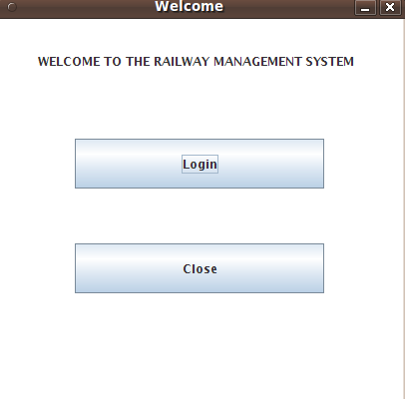

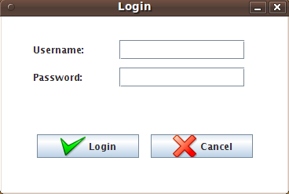

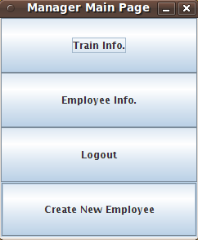

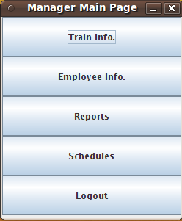

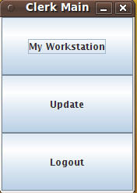

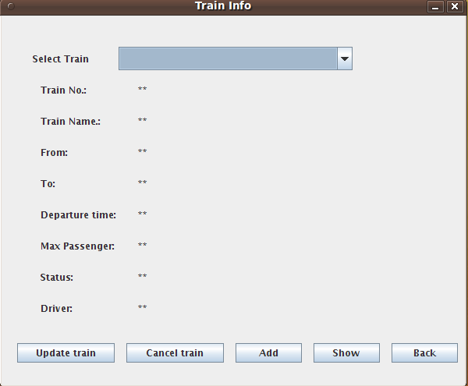

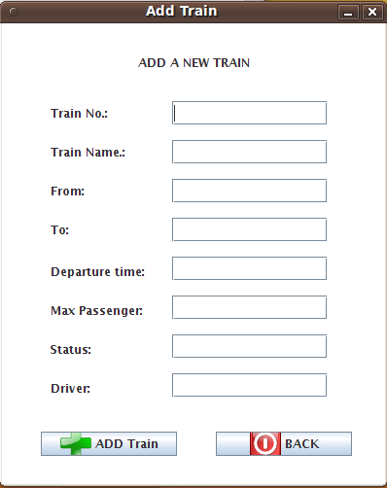

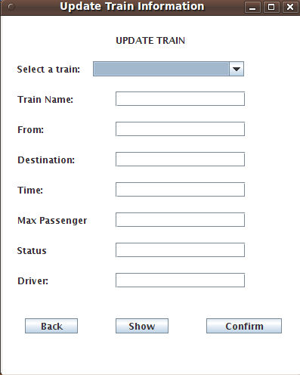

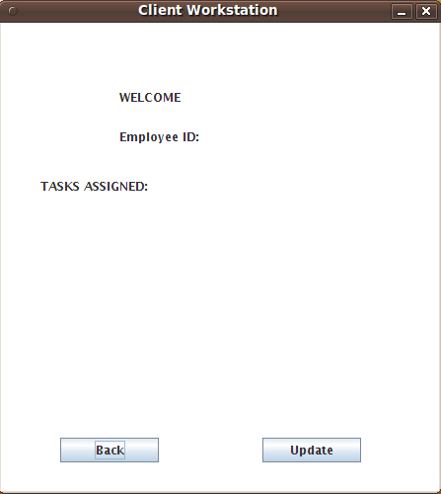

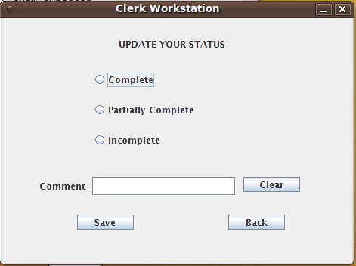

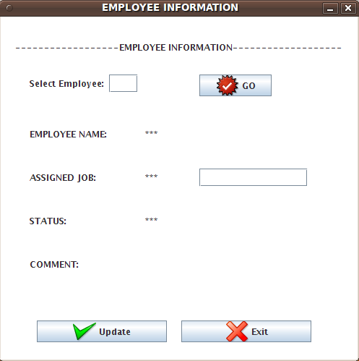

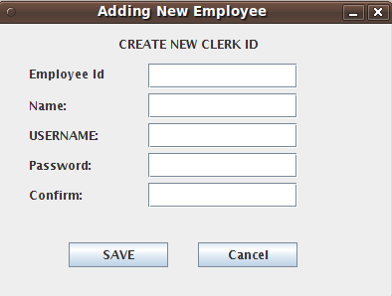

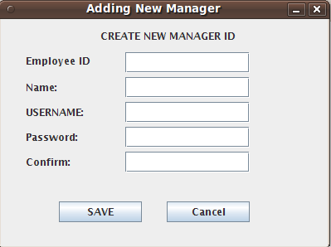

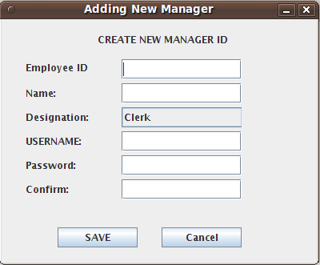

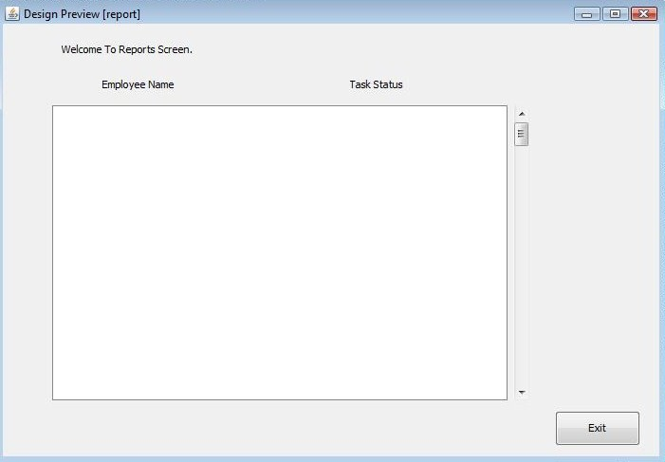

**6.BIBLIOGRAPHY**

1. Head First Java 2nd Edition
2. http://java.sun.com/javase/technologies/desktop/
3. http://www.roseindia.net/jdbc/jdbc-access/CreateTable.shtml
4. http://www.jdbc-tutorial.com/
5. Java and Software Design Concepts by APress